**P<sub>nar</sub>**

P<sub>nar</sub>[(BBa_K3408000)](http://parts.igem.org/Part:BBa_K3408000) is an oxygen-free inducible promoter which can response to the ResD/E two-component regulatory system and the global regulator Nitrate Reductase Regulator (FNR) of <i>Bacillus subtilis</i>.

In our gene circuit, we use P<sub>nar</sub> to control expression of phytase in the intestine of earthworm, which is an anaerobic condition. According to the paper (Jin, et al., 2018), P<sub>nar</sub> with three levels of strength were designed and applied in <i>E.coli</i> successfully(Fig.1.). The expression level of GFP in the control of high-strength promoter was 19.7 folds as the wild-type promoter. Since we wanted phytase to express as much as possible, we chose the high-strength P<sub>nar</sub>.

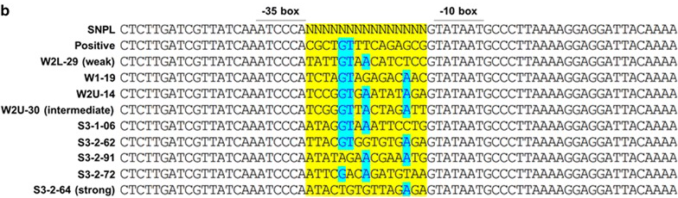

Fig.1. Sequence of promoter P<sub>nar</sub> with three levels of strength.

The spacer sequence of 15 bp between the -35 and -10 elements of the upstream region of the wild-type nar promoter was randomized (Hwang Hee Jin, et al., <i>*BIOTECHNOL BIOFUELS</i>*. 2018)

**phy(ycD)**

Phytase is a kind of phosphate-solubilizing enzyme, which can hydrolyze phytate to produce phosphate.

Considering the limitation of pH, we chose the phytase which could work efficiently under pH 6.0 to pH 7.0. We have found the phy(ycD) [(BBa_K3408001)](http://parts.igem.org/Part:BBa_K3408001) from <i>Bacillus subtilis</i> YCD whose optimum reaction pH is 6.5(Fig.2.). Thus, we constructed phy(ycD) gene into our engineered bacteria.

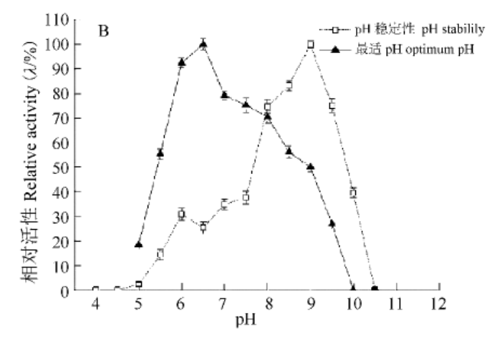

Fig.2. Effects of pH on the phytase activity (Wang Xi, et al., <i>Applied and Environmental Biology</i>. 2014)

**toehold switch**

The toehold switch consists of a cis-repressing switch RNA hairpin and a trans-acting trigger RNA.

**Switch RNA**

The switch RNA contains the coding sequence of the regulated gene. The upstream of the coding sequence is a hairpin structure which contains RBS, the start codon and a common 21nt-linker sequence. The 5'end of the hairpin provides a binding site for the trigger RNA. The binding of the trigger RNA to an unpaired toehold sequence of the switch hairpin allows for a branch migration process, exposing the start codon and ribosome binding site for translation initiation.

We used the toxin protein gene mazF as the regulated gene, so when trigger RNA binds to the switch RNA [(BBa_K3408003)](http://parts.igem.org/Part:BBa_K3408003), MazF protein will be expressed to kill bacteria.

**Trigger RNA**

Trigger RNA is a short RNA sequence that can bind to the switch RNA to initiate translation of downstream gene.

In our gene circuit, we need high stability and long half-life of trigger RNA. Based on literature, we found that 5' hairpin can improve stability of mRNA (Fig.3.). By imitating this design, we added 5’ hairpin to trigger RNA to meet our need.

x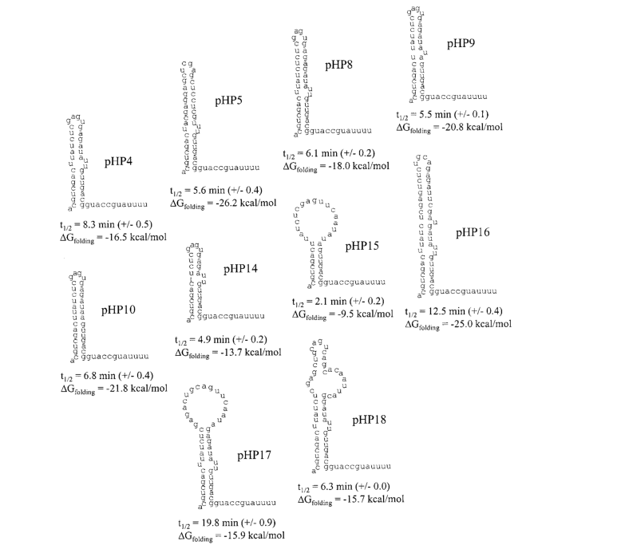

Fig.3. Effect of different Synthetic 5' Secondary Structures to half-life of mRNA (Carrier T A, et al., <i>Biotechnology Progress</i>. 2010)

**Optimized CⅠ**

We optimized the CⅠ protein[(BBa_K3408004)](http://parts.igem.org/Part:BBa_K3408004) based on [ThermoFisher SCIENTIFIC](https://www.thermofisher.com/us/en/home/life-science/cloning/gene-synthesis/geneart-gene-synthesis/geneoptimizer.html)(链接https://www.thermofisher.com/cn/zh/home/life-science/cloning/gene-synthesis/geneart-gene-synthesis/geneoptimizer.html) to make it more suitable for our engineered bacteria.

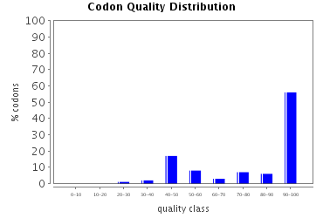

Fig.4. Codon quality distribution

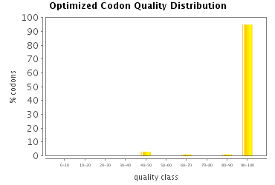

Fig.5. Optimized codon quality distribution

The histograms show the percentage of sequence codons which fall into a certain quality class. The quality value of the most frequently used codon for a given amino acid in the desired expression system is set to 100, the remaining codons are scaled accordingly (see also Sharp, P.M., Li, W.H., Nucleic Acids Res. 15 (3),1987).

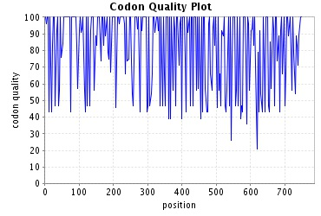

Fig.6. Codon quality plot

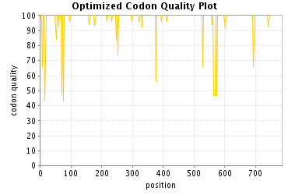

Fig.7. Optimized codon quality plot

The plots show the quality of the used codon at the indicated codon position.

**Optimized DpnI**

<i>Bacillus subtilis</i> has been increasingly applied in genetic engineering due to its powerful secretion capacity. As a restriction enzyme which is capable of cutting all methylated DNA, optimized DpnI[(BBa_K3408005)](http://parts.igem.org/Part:BBa_K3408001) via codon optimization can be applied in <i>Bacillus subtilis</i> more efficiently.

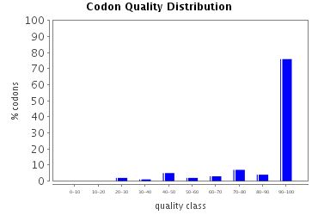

Fig.8. Codon quality distribution

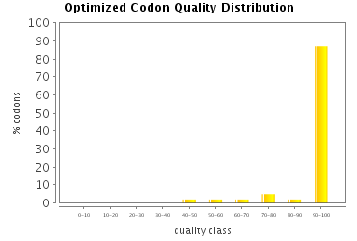

Fig.9. Optimized codon quality distribution

The histograms show the percentage of sequence codons which fall into a certain quality class. The quality value of the most frequently used codon for a given amino acid in the desired expression system is set to 100, the remaining codons are scaled accordingly (see also Sharp, P.M., Li, W.H., Nucleic Acids Res. 15 (3),1987).

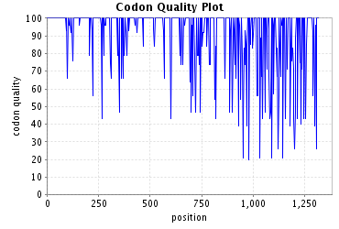

Fig.10. Codon quality plot

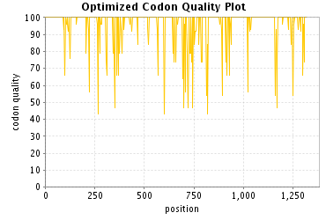

Fig.11. Optimized codon quality plot

The plots show the quality of the used codon at the indicated codon position.



engineered bacteria would be discharged to the excrement of earthworms.

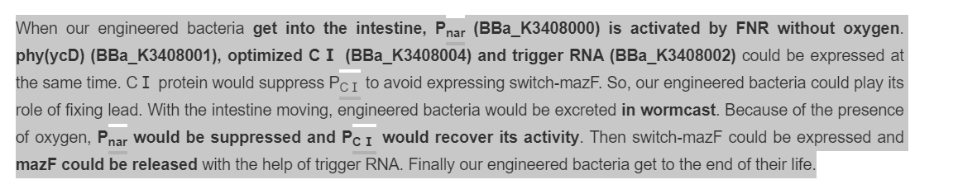

When our engineered bacteria enter the intestine of earthworm, P<sub>nar</sub> (BBa_K3408000) will be activated by FNR in anaerobic condition, so phy(ycD) (BBa_K3408001), optimized CⅠ (BBa_K3408004) and trigger RNA (BBa_K3408002) will produce. Our engineered bacteria can secrete phytase but not suicide. After a period of time, engineered bacteria is discharged to the wormcast. In aerobic condition, P<sub>nar</sub> will be inhibited but P<sub>CⅠ</sub> will recover activity. Then switch RNA can be transcribed and combine with trigger RNA. Finally, MazF protein will be produced to kill our engineered bacteria.